

**Arrange by :**

Iqbal Setyo Nugroho

Mindy Atikah Chiara Gyver

Rafif Agdyaputra

**1SC6**

**Faculty :**

Mr. Tri Agus Riyadi, M.T

**CCIT Fakultas Teknik-Universitas Indonesia**

**Kampus Baru UI Depok 16424**

**Project On**

Republic Shoes

Developed by

Name : Iqbal Setyo Nugroho

Mindy Atikah Chiara Gyver

Rafif Agdyaputra



**REPUBLIC SHOES**

Batch Code: ( )

Start Date: October 2017

End Date: October 20, 2017

Name of the Coordinator: Mr. Tri Agus Riyadi MT.

Names of Developer:

* Iqbal Setyo Nugroho
* Mindy Atikah Chiara Gyver
* Rafif Agdyaputra

Date of Submission: October 20, 2017



**CERTIFICATE**

This is to certify that this report titled Republic Shoes embodies the original work done by, Iqbal Setyo Nugroho, Mindy Atikah Chiara Gyver and Rafif Agdyaputra in partial fulfillment of their course requirement at NIIT.

Coordinator:

Tri Agus Riyadi MT.





**ACKNOWLEDGEMENT**

Authors would like to praise to Allah, Most Merciful bless and so authors can finish this Project 2 entitled “Republic Shoes”. Author would like to thanks to Mr. Tri Agus Riyadi, M.T as Lecturer who has given useful suggestion which are help author in writing this paper.

The writer realized that this paper far from perfection, then the writer will be very unfettered the chest and was encouraged, if colleagues and the guide's agreeing lecturer gave the suggestion & criticism for this paper perfection.



**SYSTEM ANALYSIS**

**System summary :** Republic Shoes is shoes store sales program, mainly selling sport shoes for man. Republic Shoes is a one brand shoes store. This program can only make transaction of one item at one time but the quantity of the item can be more than one.

**System Processes :** Republic Shoes is a program for a store offline shoes store.

**FLOWCHART**

**System process:** Login

This flowchart represents the main system process of Republic Shoes

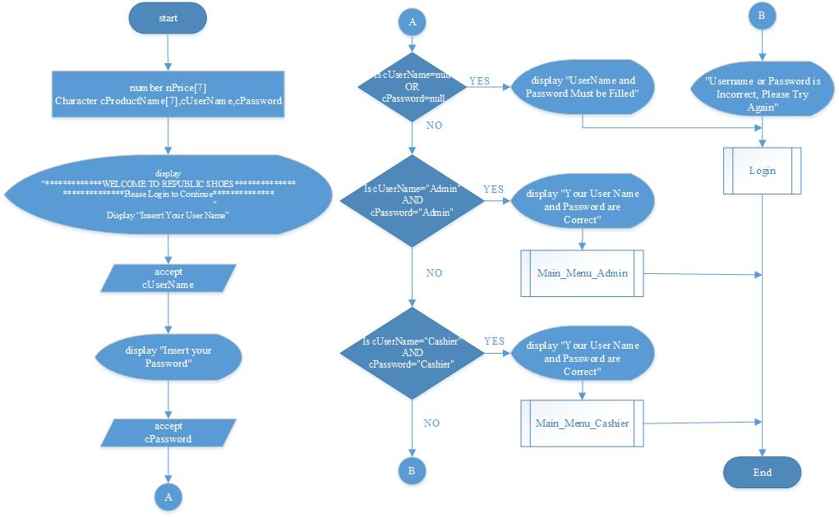

**FLOWCHART**

**System process:** Main_Menu_Admin

This flowchart represents the main system process of Republic Shoes

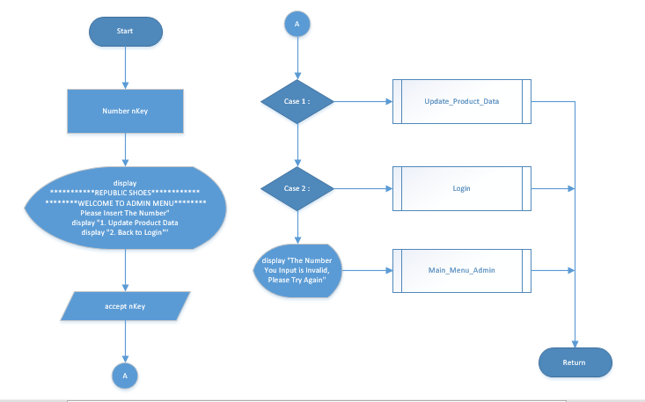

**FLOWCHART**

**System process:** Main_Menu_Cashier

This flowchart represents the main system process of Republic Shoes

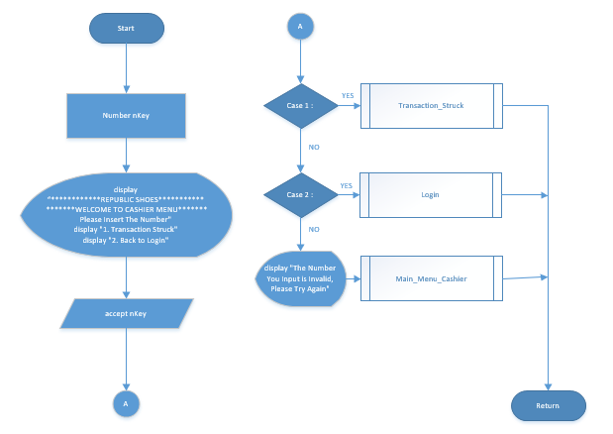

**FLOWCHART**

**System process:** Procedure Update_Product_Data

This flowchart represents the main system process of Republic Shoes

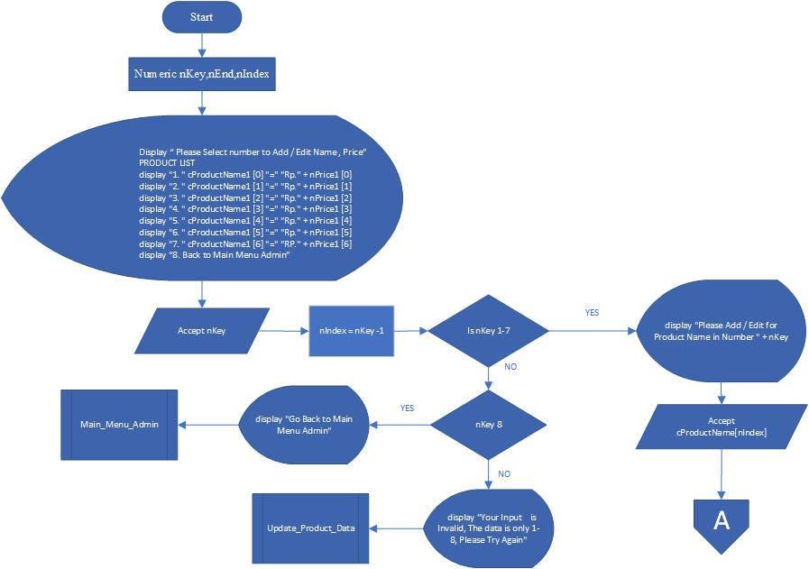

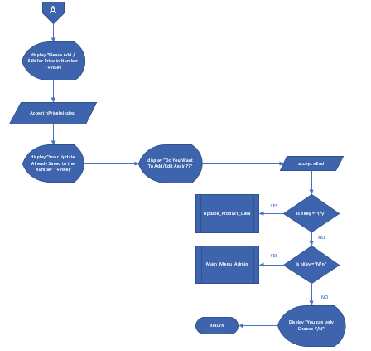

**FLOWCHART**

**System process:** Procedure Transaction_Struck

This flowchart represents the main system process of Republic Shoes

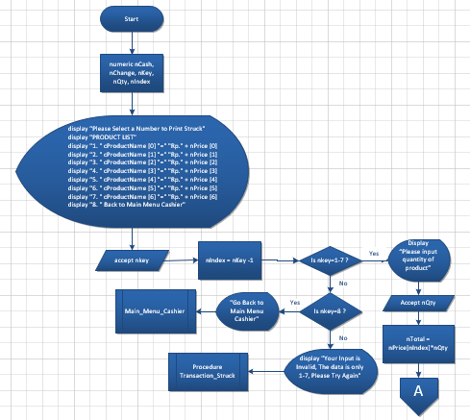

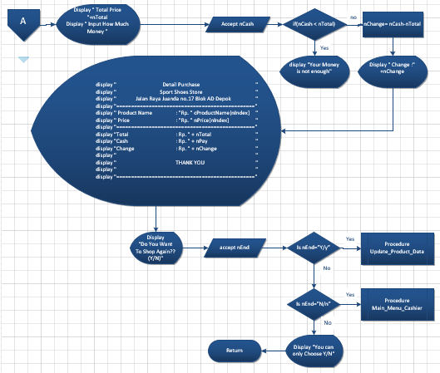

**Pseudocode**

**System Process**: Procedure Login

This pseudocode represents the main system process of Republic Shoes

Procedure Login

begin

number nPrice[7]

character cProductName[7], cUserName, cPassword

nPrice1[0] = 160.000

nPrice1[1] = 180.000

nPrice1[2] = 205.000

nPrice1[3] = 250.000

nPrice1[4] = 230.000

nPrice1[5] = 300.000

nPrice1[6] = null

cProductName1[0] = "Running"

cProductName1[1] = "Basket"

cProductName1[2] = "Badminton"

cProductName1[3] = "Soccer"

cProductName1[4] = "Futsal"

cProductName1[5] = "Hiking"

cProductName1[6] = null

display

"*************WELCOME TO REPUBLIC SHOES**************

**************Please Login to Continue**************”

//Login form

display "Insert Your User Name"

accept cUserName

display "Insert Your Password"

accept cPassword

//Logic

if(cUserName="") OR (cPassword="")//If the User Name or Password Blank

begin

display "UserName or Password Must be Filled"

call Login

end

//If the User Name and Password is Admin

else if (cUserName="Admin") AND (cPassword="Admin")

begin

display "Your User Name and Password are Correct"

call Main_Menu_Admin

end

else if (cUserName="Cashier") AND (cPassword="Cashier") //If the User Name and Password is Cashier

begin

display "Your User Name and Password are Correct"

call Main_Menu_Cashier

end

else //If the User Name or Password is not Admin/Cashier

begin

display "Username or Password is Incorrect, Please Try Again"

call Login

end

end

end

**Pseudocode**

**System Process**: Procedure Main_Menu_Admin

This pseudocode represents the main system process of Republic Shoes

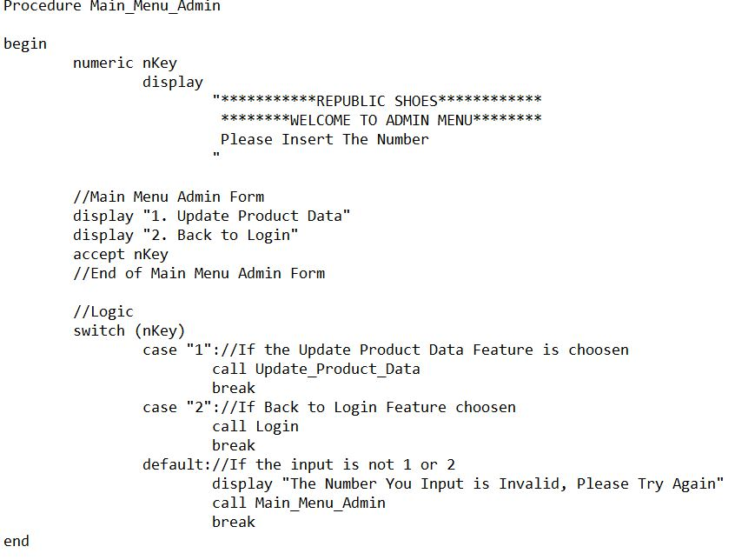

**Pseudocode**

**System Process**: Procedure Main_Menu_Cashier

This pseudocode represents the main system process of Republic Shoes

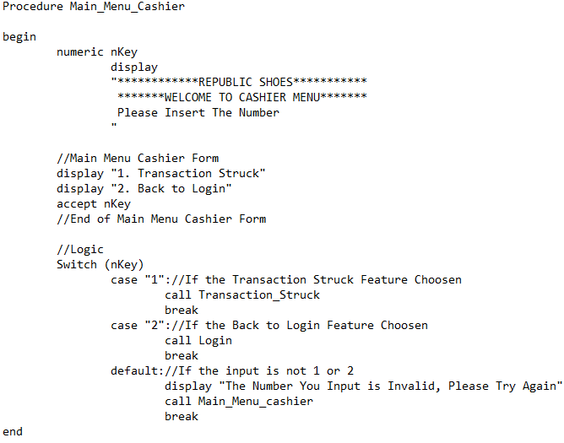

**Pseudocode**

**System Process**: Procedure Update_Product_Data

This pseudocode represents the main system process of Republic Shoes

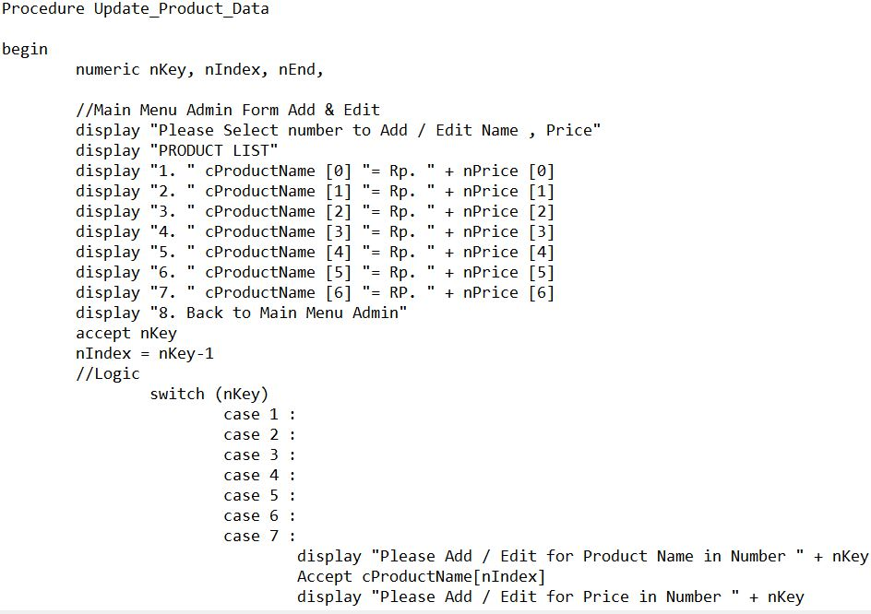

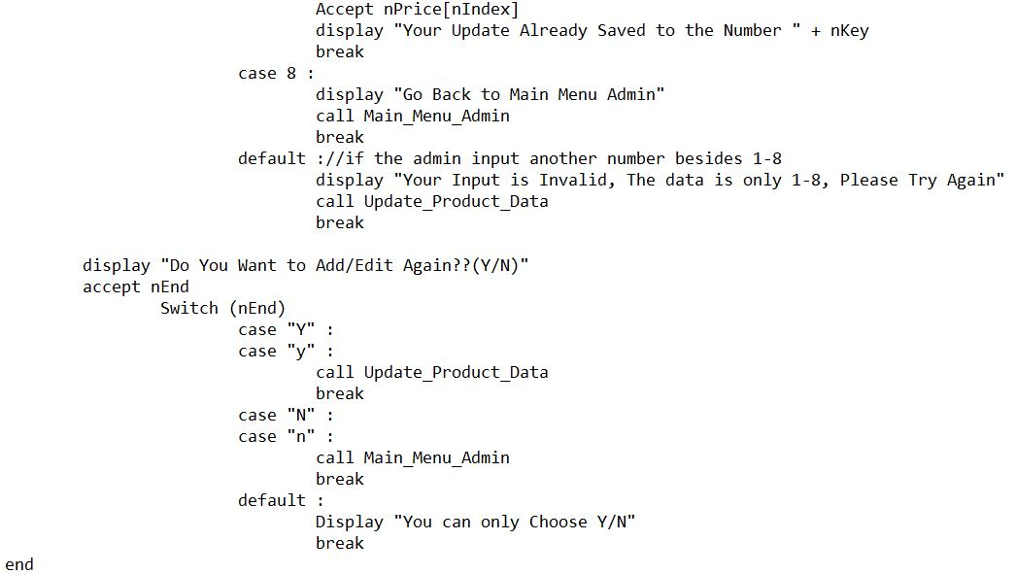

**Pseudocode**

Procedure Transaction_Struck

begin

numeric nCash, nChange, nKey, nQty, nIndex

//Product List in Transaction Struck

display "Please Select a Number to Print Struck"

display "PRODUCT LIST"

display "1. " cProductName [0] "=" "Rp." + nPrice [0]

display "2. " cProductName [1] "=" "Rp." + nPrice [1]

display "3. " cProductName [2] "=" "Rp." + nPrice [2]

display "4. " cProductName [3] "=" "Rp." + nPrice [3]

display "5. " cProductName [4] "=" "Rp." + nPrice [4]

display "6. " cProductName [5] "=" "Rp." + nPrice [5]

display "7. " cProductName [6] "=" "Rp." + nPrice [6]

display "8. Back to Main Menu Cashier"

accept nKey

nIndex = nKey - 1

//End of Product List in Transaction Struck

//Logic Product Name Selected

Switch (nKey)

case 1 :

case 2 :

case 3 :

case 4 :

case 5 :

case 6 :

case 7 :

Display " Please input quantity of product"

Accept nQty

nTotal = nPrice[nIndex]*nQty

Display "Total Price = "+nTotal

Display "Input How Much Money"

Accept nCash

if(nCash < nTotal)

begin

display "Your Money is not enough"

end

else

begin

nChange = nCash-nTotal

end

end

Display " Change :" +nChange

//Print Struck

display "****************Detail Purchase****************"

display "***************Sport Shoes Store***************"

display "*****Jalan Raya Juanda no.17 Blok AD Depok*****"

display "==============================================="

display " Product Name : " cProductName[nIndex]

display " Price : Rp. " nPrice[nIndex]

display "==============================================="

//Calculation Process

display "Total : Rp. " + nTotal

display "Cash : Rp. " + nPay

display "Change : Rp. " + nChange

display "***********************************************"

display "*******************THANK YOU*******************"

display "***********************************************"

display "==============================================="

break

case 8 :

display "Go Back to Main Menu Cashier"

call Main_Menu Cashier

break

default :

display "Your Input is Invalid, The data is only 1-8, Please Try Again"

call Transaction_Struck

break

display "Do You Want To Shop Again?? (Y/N)"

accept nEnd

Switch (nEnd)

case "Y" :

case "y" :

call Transaction_Struck

break

case "N" :

case "n" :

call Main_Menu_Cashier

break

default :

Display "You can only Choose Y/N"

break

end

**System Process**: Procedure Transaction_Struck

This pseudocode represents the main system process of Republic Shoes

case 5 :

case 6 :

case 7 :

Display " Please input quantity of product"

Accept nQty

nTotal = nPrice[nIndex]*nQty

Display "Total Price = "+nTotal

Display "Input How Much Money"

Accept nCash

if(nCash < nTotal)

begin

display "Your Money is not enough"

end

else

begin

nChange = nCash-nTotal

end

end

Display " Change :" +nChange

//Print Struck

display "****************Detail Purchase****************"

display "***************Sport Shoes Store***************"

display "*****Jalan Raya Juanda no.17 Blok AD Depok*****"

display "==============================================="

display " Product Name : " cProductName[nIndex]

display " Price : Rp. " nPrice[nIndex]

display "==============================================="

display "Total : Rp. " + nTotal

display "Cash : Rp. " + nPay

display "Change : Rp. " + nChange

display "***********************************************"

display "*******************THANK YOU*******************"

display "***********************************************"

display "==============================================="

break

case 8 :

display "Go Back to Main Menu Cashier"

call Main_Menu Cashier

break

default :

display "Your Input is Invalid, The data is only 1-8, Please Try Again"

call Transaction_Struck

break

display "Do You Want To Shop Again?? (Y/N)"

accept nEnd

Switch (nEnd)

case "Y" :

case "y" :

call Transaction_Struck

break

case "N" :

case "n" :

call Main_Menu_Cashier

break

default :

Display "You can only Choose Y/N"

break

end

**Dry Run Table**

**System Process**: Main System

This dry run table tests the main program of Republic Shoes

